Name: Daljeet Singh
StudentID: 3169763
PART I-A
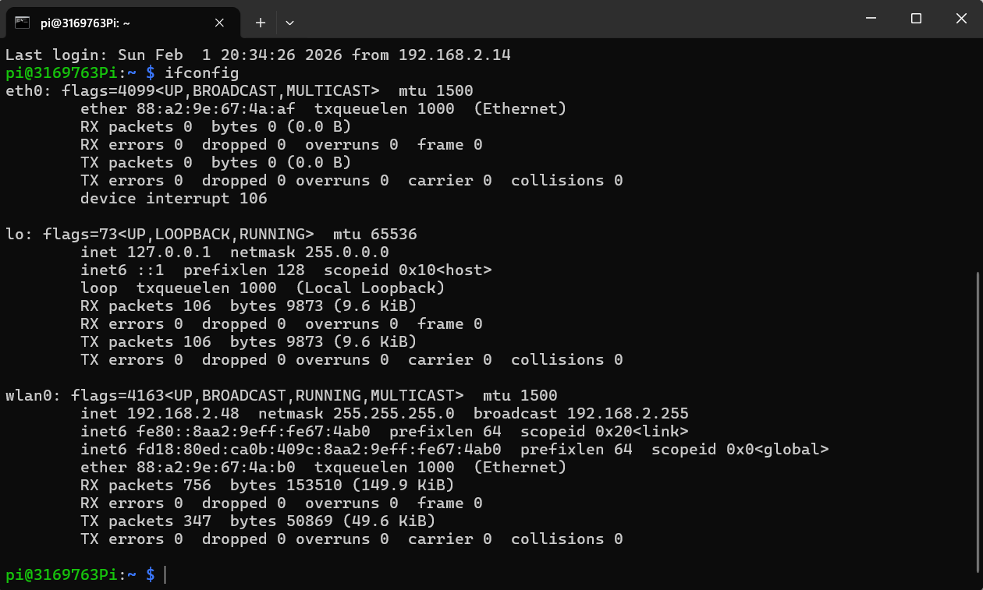

PART II

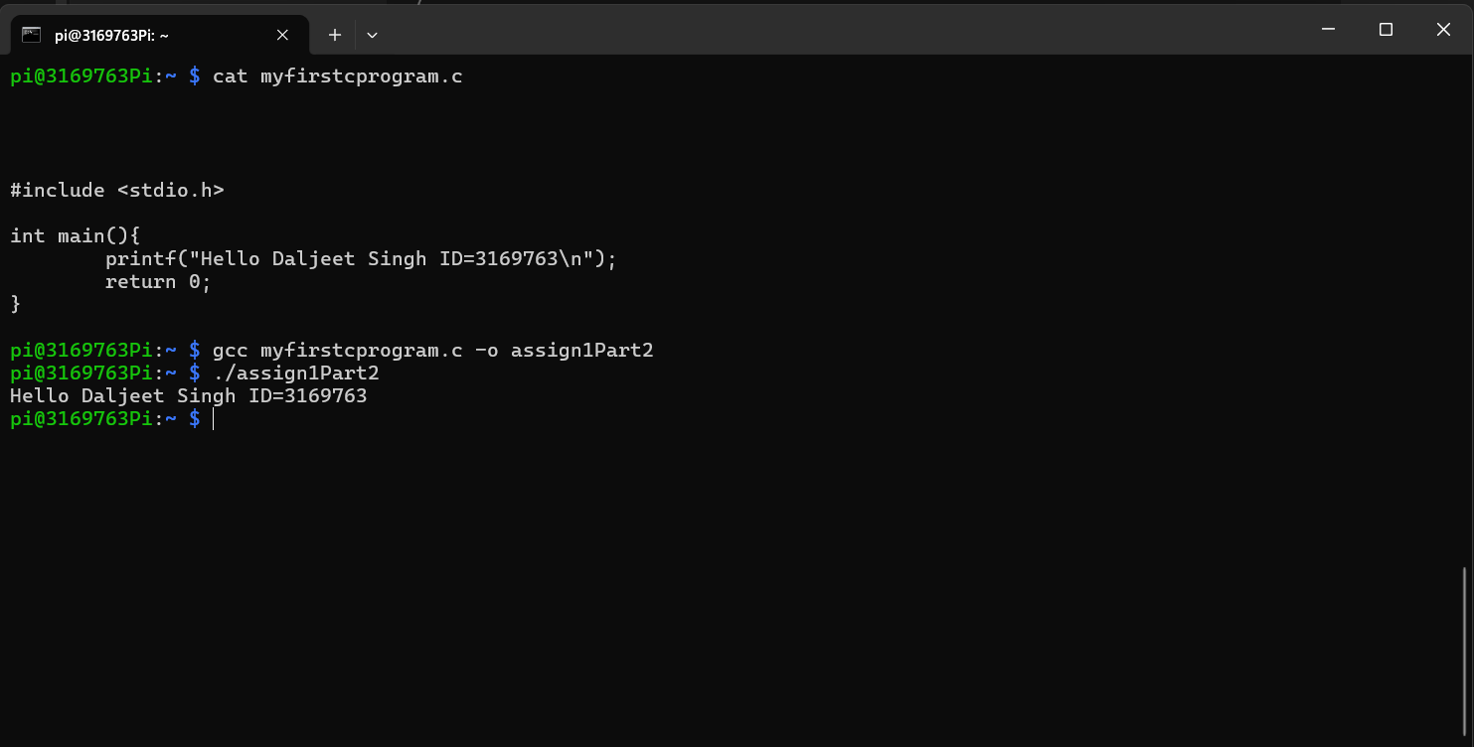

PART III
Task I.1
After running the chsh command, the shell shown by ps -p $$ did not change and continued to display bash. Chsh only changes the default login shell for future sessions and does not affect the shell that is already running. Once user logs out and logs back in, the new default shell(/user/bin/dash) will take effect.

Task I. 2
chsh -s /bin/bash

Task II.1

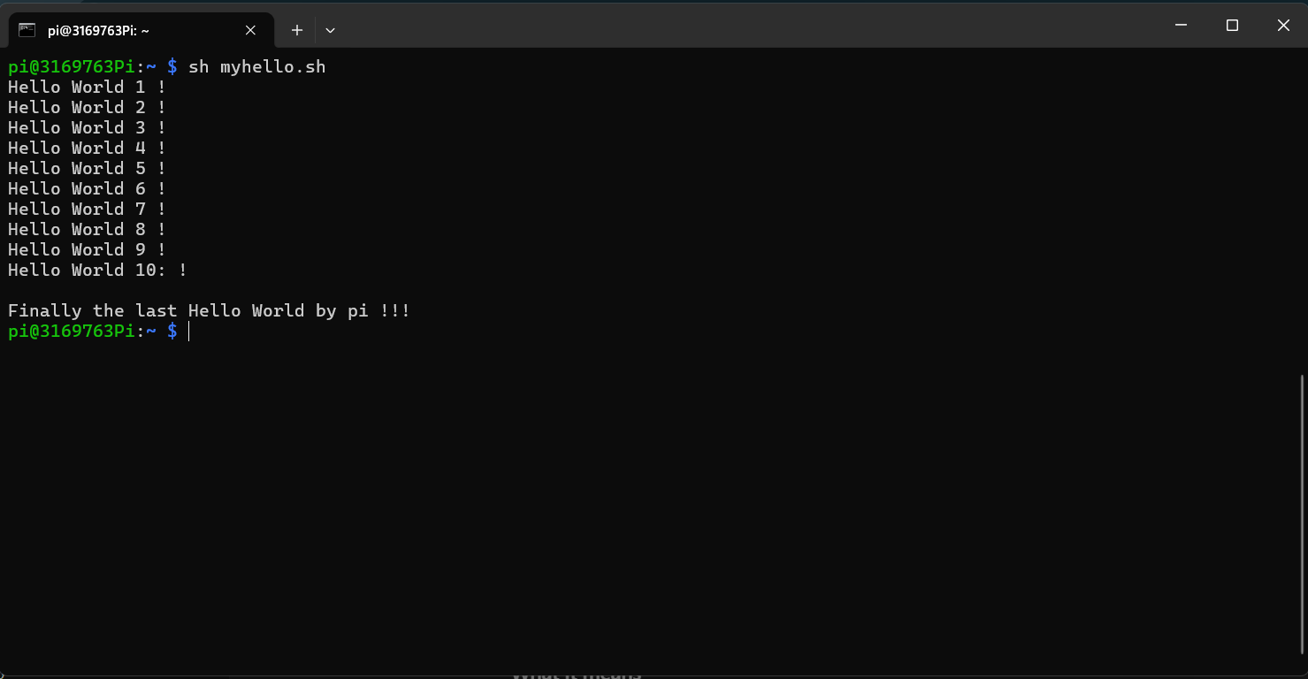

Task III.1
/bin: Essential user commands(ls,cp,cat)
/boot: bootloader files, kernel
/dev: Device files(disks, terminals, USB devices)
/etc: System-wide configuration files
/home: Home directories for user
/lib: Essential shared libraries for/bin and /sbin
/lost+found: used by filesystem to recover corrupted or lost files
/media: Temporary mount point for removable media like USB driver and CDs
/mnt: Temporary mount point for manually mounted filesystems.
/opt: Stores optional or third-party software packages.
/proc: A virtual filesystem that provides system and process information.
/root: Home directory of the root.
/run: Stores runtimes data such as process IDs and sockets.
/sbin: Contains system administration commands used by root.
/srv: Stores data for the services provided by the system.
/tmp: Stores temporary files
/usr: contains user applications, libraries and documentation.
/var: stores variables data such as logos, mail and spool files

Task III. 2
- Directories which are normally with numbers, and rest are files.
- Files are mostly owned by the pi. But sometimes they are also some files with owner like _rpc, avahi
- Mostly the same people which owns the files.

Task III.3
- Shell finishes reading the package lists but permissions is denied when performing
- The shell finishes reading the packages lists successfully without any error.

Task IV.1
Enabled: This indicates that the service is configured to launch automatically when the system starts. In essence, a link is established that initiates the app as the Pi powers on. It's fundamentally similar to how startup applications work in Windows.

Disabled: In contrast to enabled processes, those that do not begin automatically at startup can only be initiated manually.

Masked: Strong version of disabled

Static: Items that cannot be manually enabled or disabled, these are usually dependencies that start when other service needs them.

Generated: Items that were generated dynamically by the system generator script.

Task IV.2
"OpenBSD Secure Shell Server" is what the description claims. In essence, this is the background operation that enables a system to establish an SSH connection with the Pi. In order to control the Pi via an SSH connection via the network, it continuously searches for incoming connections.

Task IV.3

- 1.554 seconds
- List of currently running services with the amount of time they took to boot up
- current status of ssh server
- cron service, also says in green that it is running
- restarts the cron service, makes an Authentication required window pop up that requires a password to restart the service
- By using the keyword sudo

Task IV.4
Two processor were running, one was bash and the other process was ps

Task IV.5

